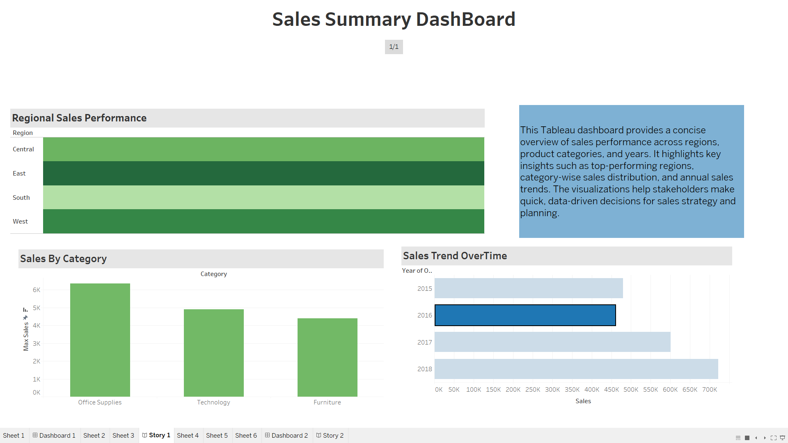

**Sales Summary Dashboard – Overview**

This dashboard offers a high-level analysis of sales data across **regions**, **product categories**, and **years**, enabling a quick understanding of performance patterns and trends. It is designed to support strategic decision-making for sales and marketing teams.

### Key Insights:

* **Regional Sales Performance**  
  The **East** and **West** regions are leading in sales volume, with consistent performance compared to other zones like Central and South.
* **Sales by Category**  
  The **Technology** category dominates product sales, followed by Office Supplies and Furniture, indicating strong market demand in the tech sector.
* **Sales Trend Over Time**  
  Sales have shown a consistent upward trend, peaking in **2018**, suggesting positive growth and successful business scaling over the analyzed years.

**Purpose**

This dashboard enables:

* Quick comparative analysis across different business segments
* Identification of growth areas and underperforming regions/categories
* Strategic planning based on year-wise performance trends

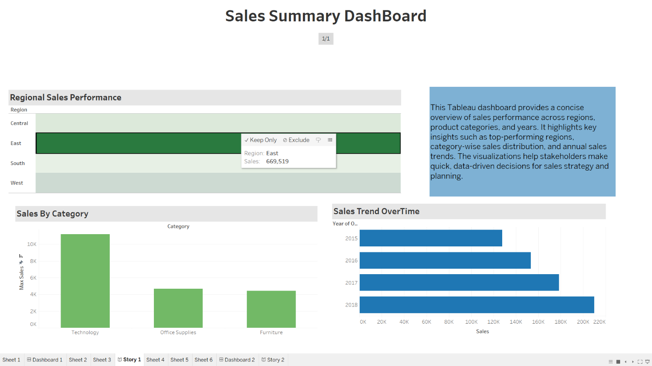

Here when the Particular Region is highlighted (for ex: East), then it shows the graph trends related to the regional sales,Similarly we have some more Regions such as Central,South and West.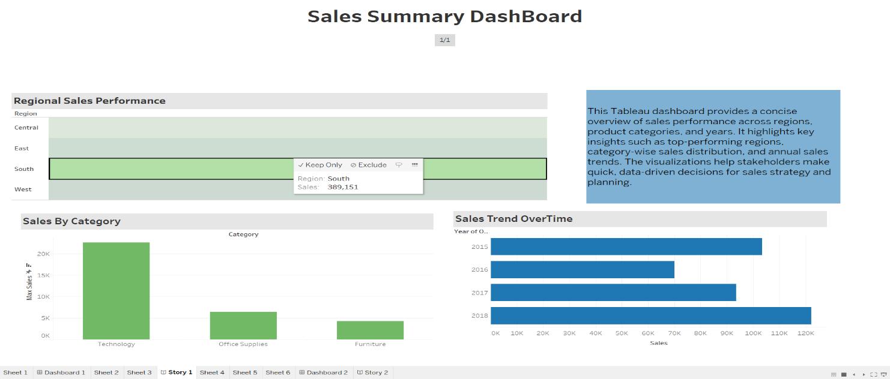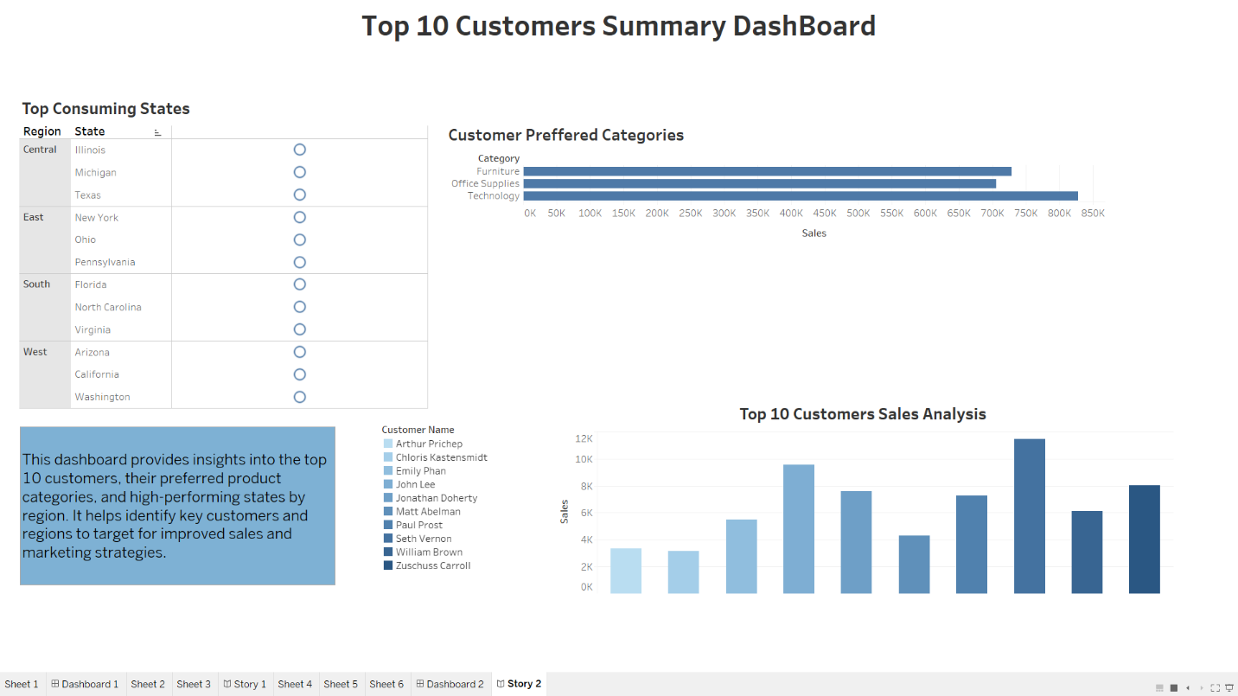

This Tableau dashboard highlights:

* The **top 10 customers**
* Their **preferred product categories**
* High-performing **states** within each region

It's designed to help businesses **identify key customers and target regions** to enhance marketing and sales strategies.

#### 1. 🗺️ **Top Consuming States by Region**

* Each region (Central, East, South, West) shows three states contributing significantly to sales.
  + **Central**: Illinois, Michigan, Texas
  + **East**: New York, Ohio, Pennsylvania
  + **South**: Florida, North Carolina, Virginia
  + **West**: Arizona, California, Washington

#### 2. 📦 **Customer Preferred Categories**

* **Technology** is the most preferred category, with sales nearing **850K**.
* Followed by **Office Supplies** (~750K) and **Furniture** (~700K).
* Indicates strong demand for tech-related products among top customers.

#### 3. 👥 **Top 10 Customers Sales Analysis**

* Displays individual sales performance for the top 10 customers.
* **William Brown** appears to be the top customer with sales around **12K**.
* Others like **John Lee** and **Seth Vernon** also show notable sales.

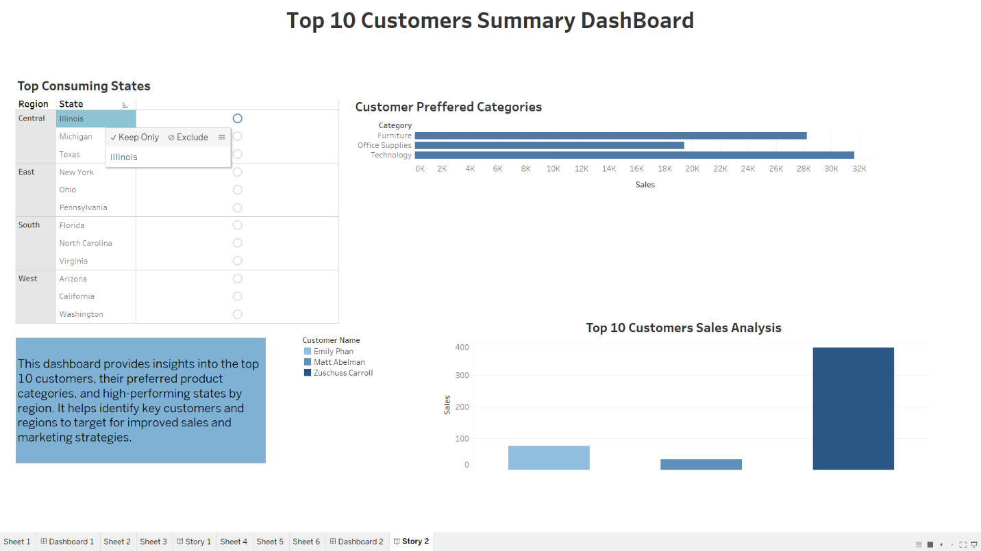

When Each Tab is Clicked You get directed to the Analysis part where everything gets easy and hands-on Experience

